General Introduction

Earlier comparative studies of fetal and adult wound healing have hypothesised that the larger inflammatory response of adults may be an evolutionary strategy for faster healing but more extensive scarring. Anti - TGF-B (released by macrophages) therapies have been shown to reduce scarring in rats, adult wound repair and . Other work has showed TGF-B accelerates the rate of healing of linear incisional wounds in rats. Older people also heal slower but scar less.

During severe burns, cells are damaged (release ITM into area and blood), stem cell (e.g. hair follicle) areas can be entirely destroyed (bad for regrowth). So there is increased inflammation, bacteria, infection triggers further inflammation, which may lead to organ damage.

After a thermal injury, a variable degree of liver injury is present. This is caused by hypoperfusion, proinflammatory cytokines, cell death, formation of oedama and fatty changes. This effect is most pronounced in children, and is the sixth leading cause of death for under 14 year olds.

It is likely we will need to create a model that is spatio-temporal, as the position and distribution of the damage in a wound dramatically effects the dynamics of the inflammatory response. Non-healing, or chronic, wounds result from one or more phases of the natural, or acute, wound healing process. These overlapping phases involve an inflammatory response and associated cellular migration, proliferation, matrix deposition, and tissue remodelling.

Alkaline Phospatase and it’s role in the Immune System (from previous IAS paper)

Alkaline Phospatase (AP) can detoxify bacterial lipopolysaccharides (endotoxins) by removing the two phosphate groups found on LPS carbohydrates (Bates et al., 2007). It may function as an adaptive mechanism to help the host manage the potential toxic effects of gram-negative bacteria. It also dephosphylates extracellular nucleotides, such as ATP. These nucleotides have a different effect/role once they are outside of the cell, e.g. signaling molecules, modulation of vascular tone, electrolyte transport, mast cell degranulation, cell death, and synaptic transmission (Brake and Julius, 1996). Clearly effects such as cell death are part of the ischemic insult that results from severe burns, contributing to the damage of blood vessel tissues, reducing blood supply to the area. But, we should pay attention to whether some roles (signaling) of the ECN should not be eradicated.

AP’s other key role is the maintenance and restoration of physiological barriers. During an ischemic shock (and inflammation triggering insult) this barriers tend to become hyper-permeable and/or dysfunctional. Humans have four distinct AP isozymes: tissue-nonspecific
AP (liver/bone/kidney type AP)

This paper models systemic insult (massive amount of ITMs) from multiple sources and therefore the “tissue” represents the entire body. It is compartmentalised into: liver, blood stream, and tissue. For severe burns, and the minimisation of scarring, we most likely need to introduce a cell agent based model that is coupled to the HIIS model. There are several interlinked phases of burn wound healing, each phase of the process is dependent on the preceding spatio-temporal action of the IS. E.g. the ECM cannot be remodelled until there has been sufficient angiogenesis.

Possible: suggests ATP and H202 may establish a pro-inflammatory permissive environment to potentiate the recruitment of immune cells into the inflamed tissue. Some evidence that atp enhances response to attractant by generating a signal amplification loop (Weavers et al, 2016).

Deep (third degree) burns are so serious largely because they destroy the many hair follicles and sweat glands that invaginate deep into the dermis and serve as efficient sources of epithelial regrowth after more superficial injury.

Wound Repair and Regeneration
Eming, Sabine A et al. “Wound repair and regeneration: mechanisms, signaling, and translation.” Science translational medicine vol. 6,265 (2014): 265sr6. doi:10.1126/scitranslmed.3009337

Hypertrophic Scar | Keloid Scar
Rapid Growth | Constant Growth
Generally regress <6 months | No spontaneous regression
A SMA myofibroblasts | Extend beyond margins of tissue damage
Collagen fibers parallel to skin surface | Genetic predisposition (younger & darker skin)
Vertically orientated blood vessels | Thick, haphazardly orientated collagen bundles

Wound healing after skin injury involves extensive communication between the different cellular constituents of the diverse compartments of the skin and its extracellular matrix (ECM). (Emig et al, 2014).

Chronic Wounds (Barrier defects that have not proceded through orderly and timely reparation to regain structural and functional integrity)
- Show hyperproliferative and nonmigratory epidermis
- Unresolved inflammation
- Presence of infection
- Biofilm formation (Perpetuates the inflammatory phase of wound healing)
- Increase in inflammatory cells (neutrophilis and macrophages) but not all are properly functioning
- Uncontrolled proteases (e.g. Amylase. Enzymes that break down proteins and peptides) that interfere with essential repair mechanisms
- Some fibroblasts becomes senescent (biologically ageing)
- Reduction of angiogenesis (formation of new blood vessels from pre-existing ones)
- Reduction in stem cell recruitment and activation
- Reduction in ECM remodeling

Inflammatory Response to Wounds (Natural acute wound healing procedes through several largely overlapping phases that involve:
- Inflammatory response
- Cellular Migration
- Cellular Proliferation
- Matrix deposition
- Tissue remodeling
Interruption or deregulation of one or more phases may lead to non-healing/chronic wounds.

Inflammation helps to fight infection, clear debris and induce the proliferation phase (fibroblasts entering, then angiogenesis), but may lead to tissue damage if it lasts too long. This is often the case when: unable to clear debris, excessive detritus, devitalised tissue, or microbial biofilm is present.

Injury:
- Leads to immediate activation of the clotting cascade which:
- through the assembly of a fibrin clot
- Assures hemostasis
- Provides the matrix architecture to initiate the invasion and recruitment of inflammatory and other cells
- Platelets trapped in the clot also release growth factors and chemokines into the local wound environment (Clinical use of platelet-rich plasma to promote healing)
- early inflammatory response mobilises local and systemic defense responses to the site

Recent investigation of chronic wound tissue and fluid indicate a continual competition between inflam and anti-inflam signals leading to a misbalanced environment for proper wound healing to occur. (Eming et al, 2010; Beidler et al, 2009)

- Increased proinflammatory cellular infiltragtes composed largely of neutrophils and macrophages contribute to delayed healing
- Deregulation of key proinflam cytokines (IL-1β TNFα) prolong the inflam phase
- These cytokines increase in chronic wounds, due to them causing elevated metalloproteinases that degrade the local ECM and thus impair cell migration (Tarnuzzer and Schultz, 1996)
- Continued presence of a high bacterial load in wounds result in a sustained influx of pro-inflammatory cells and increased imflammation
- The epidermis up-regulating and secreting antimicrobia peoptides early in response to barrier damage and exposure to microbes
- Recruitment of bone marrow and endothelial progenitors to the site of injury coordinated by specific chemokines (Stem cell modulation is being explored for potential therapy but in burns the hair follicle, sebaceous gland and basal layer of the epidermis may be damaged / destroyed)
- Angiogenesis (sprouting of capillaries from existing blood vessels) and vasculogenesis (mobilization of bone marrow–derived endothelial progenitors) contribute to new blood vessel formation during tissue repair
- Inadequate local angiogenesis would lead to increased ischemic insult?
- Reduced angiogenesis leads to elevated cell death
- Macrophages are stimulated by low oxygen content to induce angiogenesis
- endothelial cell damage may lead to slower capillary growth
- members of the vascular endothelial growth factor (VEGF) family are proangiogenic factors
- Modulating the balance between pro and antiangiogenic molecules?
- Cellular senescence: oxidative stress may drive uncontrolled fibroblast proliferation and keloid formation. Senescent fibroblasts and keratinocytes secrete MMPs 2,3,9, maspin (antifibrotics)
- If epithelisation is slow, scarring is likely.

Inhibition of Alkaline Phosphatase by L-Phenylalanine (Fernley and Walker, 1970)
Tiwari, V K. “Burn wound: How it differs from other wounds?.” Indian journal of plastic surgery : official publication of the Association of Plastic Surgeons of India vol. 45,2 (2012): 364-73. doi:10.4103/0970-0358.101319
+
Computational Systems Mechanobiology of Wound Healing
Tepole 2016

- Wound Healing process relies on co-ordinated action of cells and spatiotemporal profile of cytokines
- Production and diffusion of chemical signals (PDGF and TBF-β) attract macrophages and fibroblasts
- Macrophages maintain production of TBF- β and release other factors:
  - TGF-α is a chemoattractant for keratinocytes (part of the reepithelisation process; epidermal keratinocytes CAN CONTRIBUTE TO DE NOVO HAIR FOLLICLE FORMATION during large wound healing)
  - Fibroblast growth factors (1,2,4 regulates endothelial cells during angiogenesis)
    - Fibroblasts (deposit and remodel the new ECM; also release FGF; assemble ECM by acute tissue contraction and fiber realignment)
  - VEGF (regulates endothelial cells during angiogenesis)

- Hemostasis: Platelets from the circulatory system get depoisited in the clot, degranulate and release chemotactic signals such as TGF-β and PDGF.
- Inflammation: (approx 2 days after):
  - Neutrophils are prevalent in the wound, they produce antimicrobial substances and phagocyte bacteria.
  - Second phase: Macrophages continue the immunological response to establish long-lasting chemical source of various cytokines to recruit fibroblasts, endothelial cells, and keratinocytes. TGF, FGF, PDGF, and VEGF are the key cytokines to stimulate mitosis (healthy cell division) and native skin cell migration.
  - Vascular response: Immediately after burns there is a local vasodilatation with extravasation of fluid in the third space. In extensive burn injury increased capillary permeability may be generalized leading to massive extravasation of plasma requiring fluid replacement.
  - Cellular response: Neutrophils and monocytes are the first cells to migrate at the site of inflammation. Later on neutrophils start declining and are replaced by macrophages. The migration of these cells is initiated by chemotactic factors like kallkireins and fibrin peptides released from coagulation process and substances released from the mast cells like tumour necrosis factor, histamine, proteases, leukotreins and cytokines. Cellular response helps in phagocytosis and cleaning of dead tissue and toxins released by the burned tissue.
- Proliferation: (approx weeks) Most intense regeneration of tissue.
- Keratinocytes build the new epidermis and fibroblasts assemble the new ECM in the dermis.
- In healthy skin, proliferative keratinocytes are polarised by adhering to the basement membrane, allowing them to continually renew the epidermis.
- Upon injury, these cells migrate laterally to build a new epidermis over the wounded area. Coupled to the release of growth factors from macrophages and fibroblasts (esp TGF-α and FGF7).
- Fibroblasts migrate in response to initial inflammatory signals, especially towards PDGF and TGF-β.
-Fibroblast interaction with the ECM is crucial regulator of healing.
- Fibroblasts show increased collagen deposition in the presence of TGF-β
- Mechanotransduction of TGF causes contraction of wound. Mechanical forces also translate to chemical responses.
- Fibroblasts respond to strain by altering their collagen deposition rate and producing TGFB.
- Scar tissue is characterised by thinner collagen bundles with higher degree of alignment. (https://doi.org/10.1016/j.actbio.2012.06.042 )
- Remodeling (approx months): Cells undergo apoptosis (programmed cell death). The remaining fibroblasts continue to break down the scar and reorganise the ECM.

A multi-agent cell-based model for wound contraction – Boon et al. 2016

- Excessive contraction may lead to
- Myofibroblasts exert stronger contractile forces than fibroblasts.

(http://dx.doi.org/10.1016/j.cub.2016.06.012) Systems Analysis of the Dynamic InflammatoryResponse to Tissue Damage Reveals SpatiotemporalProperties of the Wound Attractant Gradient

-Wound signal is released from the wound edge for 30 minutes and diffuses at 200 μm2/min
-Failure in normal wound repair can be used as an early prognostic marker of a non-healing wound, perhaps after fluorescent activated cell (FACS) sorting of immune cells
-?extensive injury to skin also promotes the early trafficking of a unique subclass of leukocytes (circulating fibrocytes) to the injured region?

We can use the innate model as a system effect depending on blood flow, so that processes such as angiogenesis allow for further anti inflammatory action, although less angiogenesis in non scarring healing.

Cells, Matrix, Growth Factors, and the Surgeon 1994 Adzick and Lorenz

- Fetal tissue repair does not cause scaring, and has markedly reduced inflammatory infiltrate and cytokine profile. Scarless fetal wounds are relatively deficient in the inflammatory cytokine TGFB. Scarring in adults associated with excess of TGFB.

- Fetal skin is less oxygenated, this runs counter to adult wound studies that show hypoxia can result in delayed healing, impaired leucocyte function and increased infection.

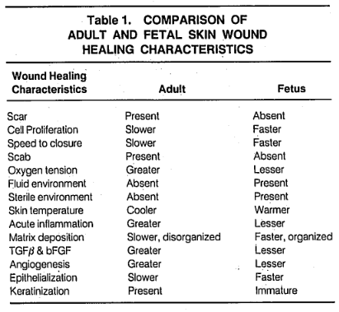

- Recent studies have correlated the absence of scarring in fetal wonds with the sparse inflammatory response (reduced macrophage and monocyte infiltrates, absens of endogenous immunoglobulins at the wound site, reduced angiogenesis, and altered levels of peptide growth factors.
- Excessive action of TGFB may be responsible for the tissue damaged caused by scarring in many diseases.
- Injecting rats with anti TGFB resulted in less scarring.
- It appears that adult wonds may be optimised for speed of healing under adverse conditions, resulting in excessive inflammatory infiltrate and cytokine profile.

Biochemical Changes in Burns – Adiga et Adiga, 2015

After a thermal injury, a variable degree of liver injury is present. This is caused by hypoperfusion, proinflammatory cytokines, cell death, formation of oedama and fatty changes. This effect is most pronounced in children, and is the sixth leading cause of death for under 14 year olds.

Oedema occurs when fluid leaks out of damaged cells, causing a buildup of substance or activity around the wound. This can also lead to the tissue surrounding the wound to not receive the efficient amounts of oxygen and nutrients necessary for healthy cell production.

An increase in edema formation in burns patients may lead to cell damage, with the release of the hepatic enzymes. Liver enzymes, such as aspartate aminotransferase (AST) and alanine amino transferase (ALT) are the most sensitive indicators of hepatocyte injury. Both AST and ALT are normally present in low concentrations. However, with cellular injury or changes in cell membrane permeability, these enzymes leak into circulation. Of the two, the ALT is the more sensitive and specific test for hepatocyte injury. These enzymes may be predictors of prognosis in burns injury.

Effects of Red Deer Antlers on Cutaneous Wound Healing in Full-thickness Rat Models Gu et al 2008

- In wounds treated with antler ointment, especially in those treated with high concentration ointment, the TGF-β levels were found to be elevated at day 8 after the wounding occurred, as opposed to the levels in the control group. Expressions in the wounds treated with antler ointment were found to continuously increase and are significantly stronger than that in the wounds treated with the Vaseline ointment. Particularly at day 16, the levels of TGF-β reached its maximum and then declined after.

Burn Surgery

Scar Formation

Cells like macrophages release soluble factors that stimulate fibroblasts to lay down connective tissue, including collagen and glycosaminoglycans. Fibrosis is the formation of excess fibrous tissue in a tissue during reparation (“normal” healing is replacement of same kind of cell). It’s function is to hold the tissue together, it has four stages: Angiogenesis, migration and proliferation of fibroblasts, deposition of ECM, remodeling of ECM. Before the process begins EPC (endothelial precursor cells, found in bone marrow and vessels) must be present,
Body forms collagen fibers (parallel instead of “basket-weave” as per) during wound repair. Collagen helps to

The present model predicts that the amount of final contraction is larger if the migration velocity of the leukocytes is larger and hence it is important that the immune system functions well to prevent contractures.

Edema and Burn Shock
https://doi.org/10.1016/S0749-0704(05)70058-0
Hemodynamic changes after burn are significant and must be managed carefully to optimize intravascular volume, maintain end-organ perfusion, and maximize oxygen delivery to the tissues. Massive fluid shifts after severe burn injury result in the sequestration of fluid in both burned and nonburned tissue. Release of proinflammatory mediators leads to increased microvascular permeability and generalized edema. Leakage of fluid through the burn wound to the environment and into the interstitial space depletes effective circulating blood volume. Furthermore, there is also direct myocardial depression from circulating factors after burn injury.

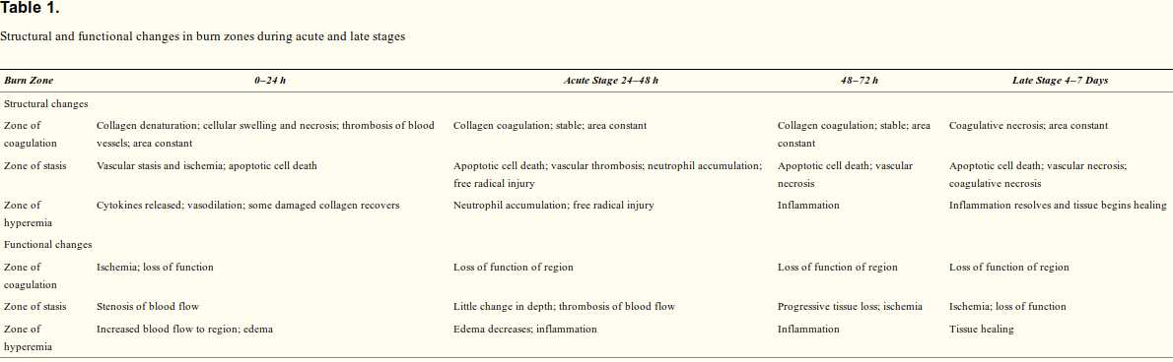
Relevant Bio-markers
- Depth of burn (2nd – 0.12 to 2.0 mm)
- Total Body surface area of burn (TBSA) (Wallace Rule of Nines)
- Burn Location/s
- Body’s response boundaries (requires imaging device) (Thatcher, Jeffrey E et al. “Imaging Techniques for Clinical Burn Assessment with a Focus on Multispectral Imaging.” Advances in wound care vol. 5,8 (2016): 360-378. doi:10.1089/wound.2015.0684)
  - Direct site of burn insult (Zone of coagulation) = Necrotic
  - Surrounding layer (Zone of stasis) = some ischemic effects (vulnerable to eventual thrombosis and necrosis
  - Outermost layer (Zone of hyperemia) = inflammation and vasodilation (ultimately recovers)
- Tissue scattering, Location of hemoglobin molecules (High hemoglobin content in the zone of hyperemia)
- Body Surface Temperature
- Macromolecular collagen structure (native or denatured) [Optical Coherence tomography]
- Sp02: 'S' indicates saturation; P indicates pulse, also SP can stands for serum pressure and 02 is oxygen. The abbreviation is a measure of the amount of oxygen affixed to hemoglobin cells within the circulatory system. [Spectral Imaging]

Relevant Socio-markers
- Age

Social Impact on Inflammatory Markers
Castagné, Raphaële et al. “A life course approach to explore the biological embedding of socioeconomic position and social mobility through circulating inflammatory markers.” Scientific reports vol. 6 25170. 27 Apr. 2016, doi:10.1038/srep25170

- Stress hormones alter biological mechanisms including inflammatory and immune responses.
- Lower education andor income is associated with a greater burden of inflammation.
- Many studies use C-Reactive protein (CRP) as a general proxy to characterise inflammatory status (others used interleukin 6 IL6, or fibrinogen, or tumour necrosis factor α (TNF-α)). However, this is limited.
- This paper instead used, a “wide range of cytokines, chemokines and proliferation factors.
- Groups found with high inflammation: manual work father, upward social mobility (compared to remained socially advantaged)

The Immune Response to Skin Trauma Is Dependent on the Etiology of Injury in a Mouse Model of Burn and Excision
- Burn injury induces a rapid systemic cytokine and chemokine responses, which differs from that of excision injury
- Burn injury induces changes in systemic monocyte and neutrophil levels that are significantly different to those induced by excision
- Changes in dendritic cell population and maturation are different following burn and excision injury
- CD4 and CD8 T–cell activation and Treg cell responses differ between burn and excision injury
- Long-term alterations in immune profiles following burn and excision injury
- Burn injury leads to suppressed acute splenic T-cell cytokine responses

Questions
- [Admin] “Additional Phase III clinical trials are currently on the way to confirm the beneficial effects of AP previously reported in CABG and valve surgery.” - What was the result of the 3rd phase clinical trials ? +& Could we get the contact details of the plastic surgeon and burn specialist?
- There seems to be a trade-off between speed of healing (faster angiogenesis and early stages) and amount of scarring. Are we trying to increase survival/recovery rate due to immune systemic shock or reduce amount of scarring in the long-term? Or both?
- Various imaging techniques can be used to measure different biomarkers, which imaging devices does the burn specialist have at the centre?

There is no single formula which is universally accepted for calculating quality and quantity of fluids required in extensive burns. All major burn units throughout the world use their own formula or modification of one of the accepted formulae.[11] This clearly shows that all these formulae are a rough guide for calculating the fluid required in extensive burns for first 24-48 hours. Actual quality and quantity is to be modified according to the hourly urine output and other vital parameters of the patient. Following are few popular and internationally accepted formulae:
- Evan's Formula –fluid requirement is 2ml/kg/% of burns for first 24 hours in addition to the daily requirement of the patient. Half of this fluid is transfused in first 8 hours and rest half in next 16 hours. As far as the type is concerned half of this fluid will be crystalloids i.e., Ringer lactate and half will be plasma.
- Brooke's Formula – It is the same as Evan's formula. Here three-fourth of the fluid used is crystalloid and one-fourth is plasma.
- Parkland Formula –Quantity is calculated as 4 ml/kg/% of burns including daily requirement of fluid. All fluid is given in the form of crystalloids.

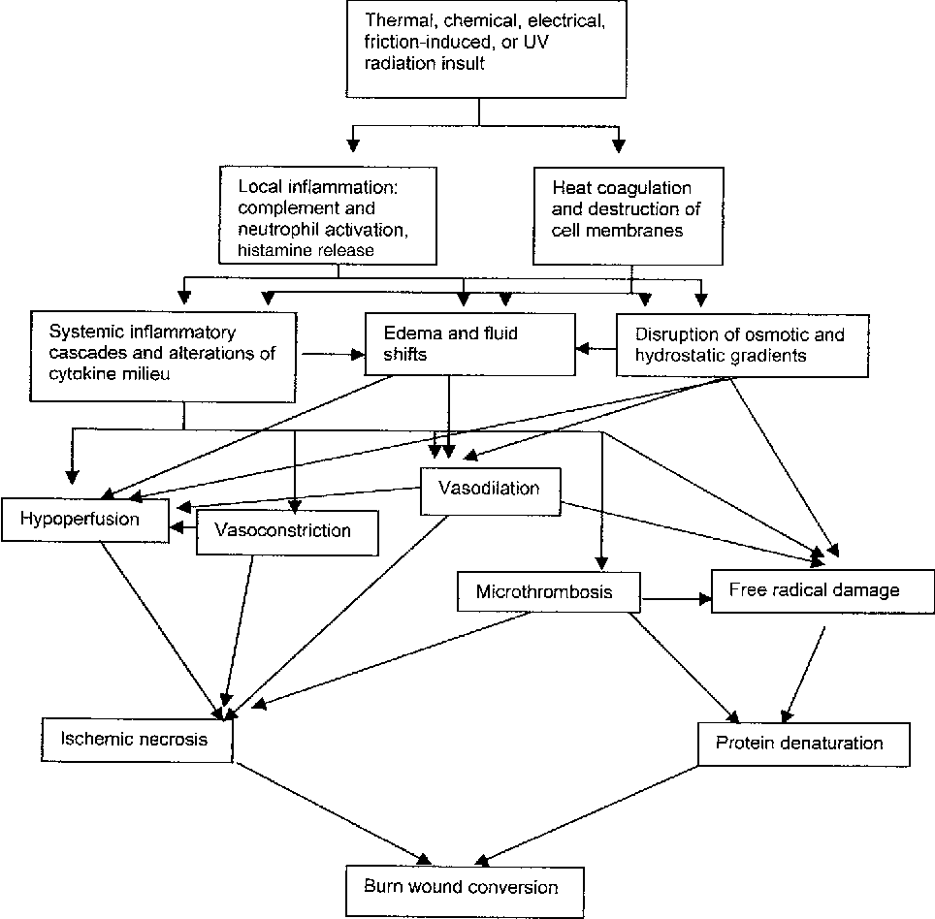

Meeting with Peter 4/30

2 main goals:
- What is necessary to adjust the ABM wound healing model to simulate burn wounds? How can we adjust it? Whats the difference with normal and burn wound healing?
- What is the role of the innate immune system in burn wounds and what is the link with the ABM model? Ruud (burn wound specialist probably knows this and Peter will setup a meeting with him, probably some specific molecule generated by immune system controlling this process)
Peter sent an email to Ruud to discuss all this. And before this meeting we gotta have e project plan (before 16th of May)! What is the plan, what kind of data is needed, what kind of biomarkers, etc! He wants to know everything, so we can ask specific questions to Ruud.

He also wants us to organise all literature in the Git page and wants access to our Github repository.
Peter wants us to present our idea on 16th of May (Thursday if possible for you).

Phase 3 clinical trial data is not available for us. Peter always arranges contact with the surgeon and burn wound specialist. And for speed/scarring trade-off, for now its more how can we adjust the ABM model to work for burn wounds.

Thats it i guess
See ya

